### Experiment – No-8

|  |  |  |
| --- | --- | --- |
| Objective: Program to print sum of even and odd numbers from 1 to N number. | | |
| Scheduled Date | Compiled Date | Submission Date |
| 09-Jan-2021 | 09-Jan-2021 | 10-Jan-2021 |

### Program : Program to print sum of even and odd numbers from 1 to N number.

### Algorithm

Step 1: Start

Step 2: Declare variable n, sum1, sum2, i

Step 3: Read the variable n.

Step 4: Apply condition:

While(i<n)

If(i%2==0)

{sum1=sum1+i}

Else

{sum2=sum2+i}

Step 5: Print

Step 6:Exit

**Program**

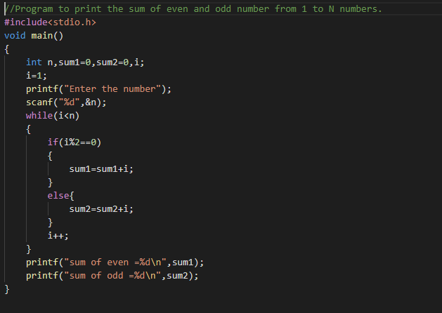

### Output Screen

### C:\Users\WIN10\Pictures\ss15.png